Ideation Phase
Brainstorm & Idea Prioritization Template

Date | 28 September 2026
Team ID | 6ab2210011b716a3e52c62c6
Project Name | Streamlining IT Procurement: Automating Standard Laptop Orders with Flow Designer
Maximum Marks | 4 Marks

Brainstorm & Idea Prioritization Template:
Brainstorming for this project focused on identifying common IT procurement challenges and generating practical ideas to streamline the process. The team explored ways to reduce manual work, improve request handling, standardize laptop orders, and provide a consistent procurement workflow using ServiceNow Flow Designer.
The ideas were grouped around procurement problems, automation approaches, request and catalog tasks, and process tracking. The final concept selected was to automate standard laptop orders through a ServiceNow Flow Designer workflow.

Step-1: Team Gathering, Collaboration and Select the Problem Statement

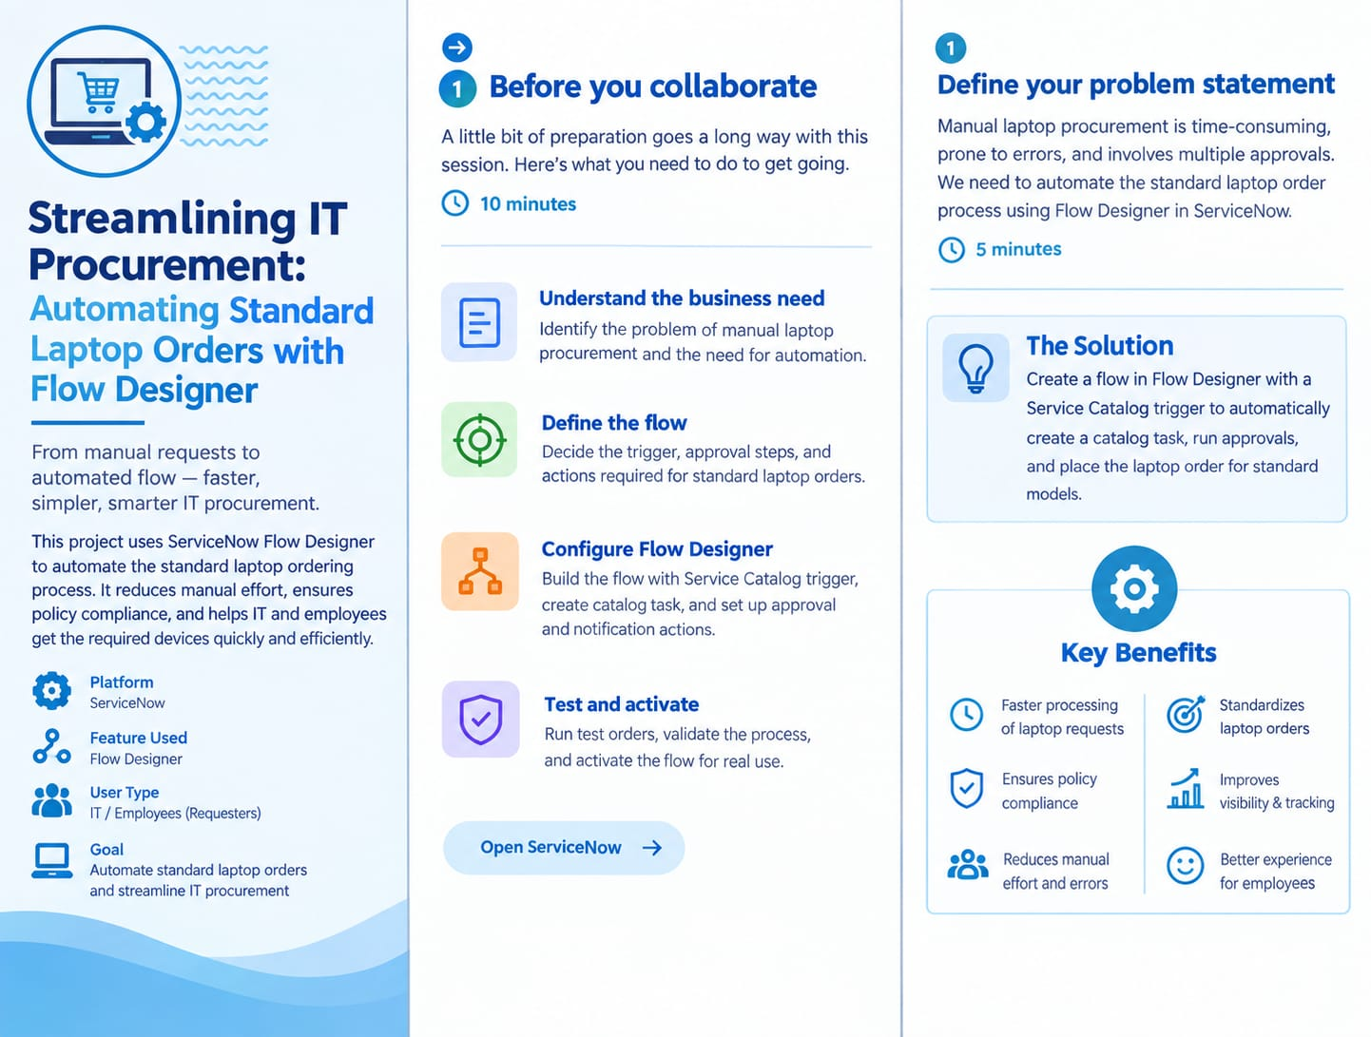

Step-2: Brainstorm, Idea Listing and Grouping
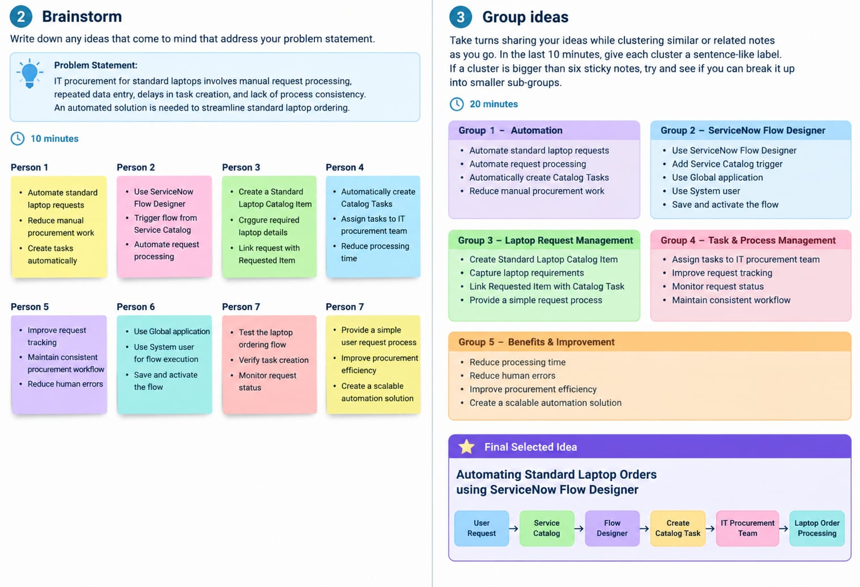
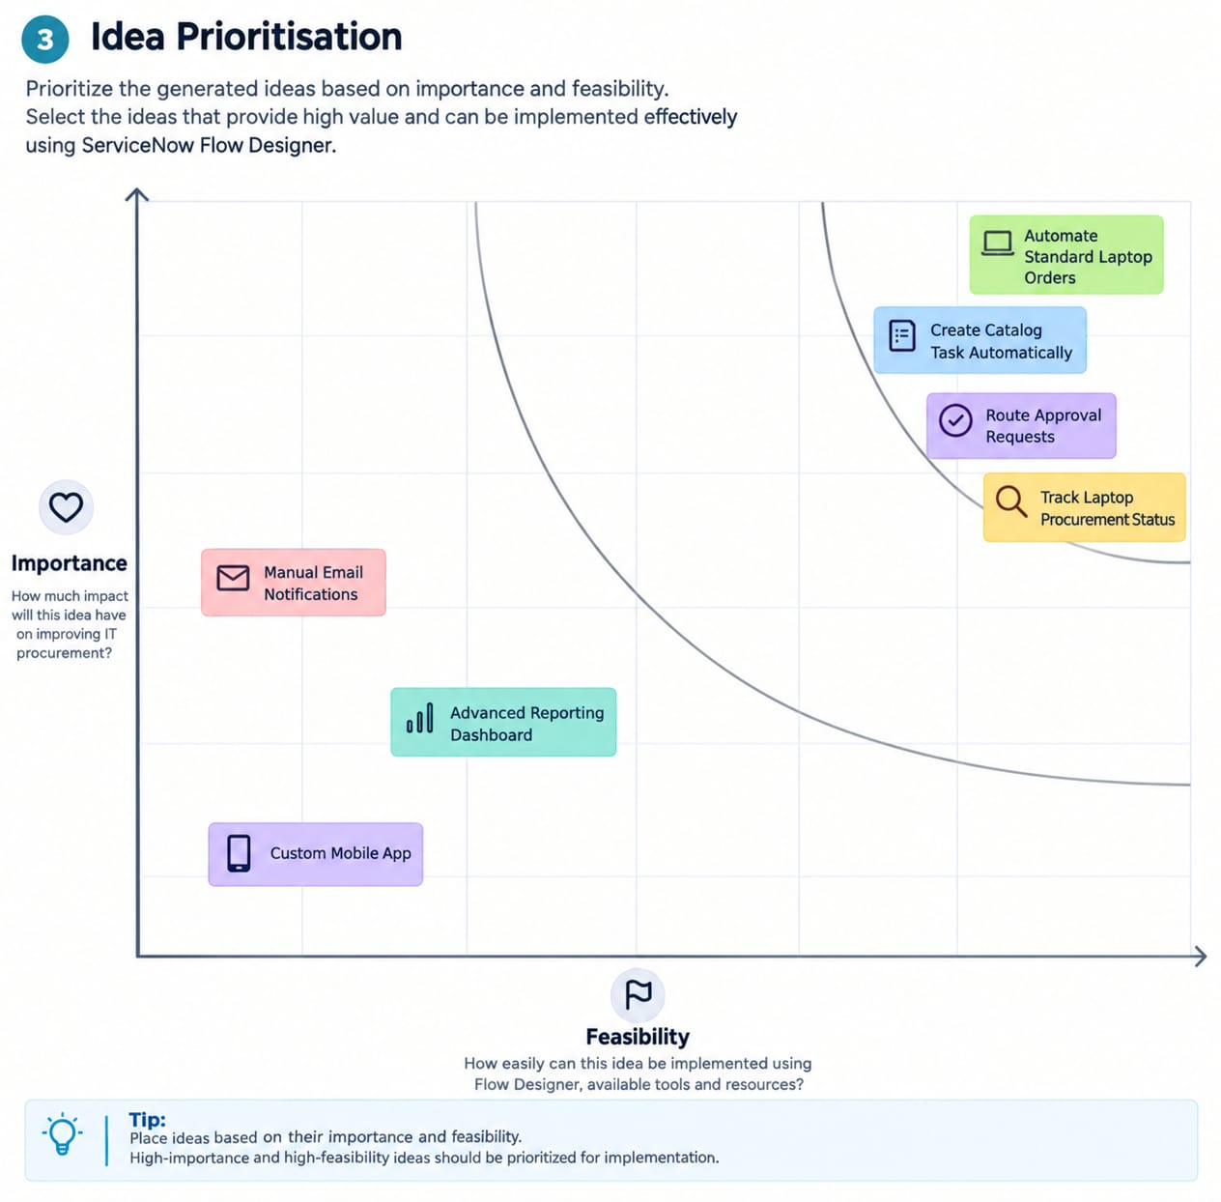
Step-3:Start Prioritisation

